AI User Experience
Informing RAD’s Point of View

Overview
At Rising, Workday introduced an updated AI strategy under the moniker Illuminate which includes 3 core pillars:
- Accelerate: leverage generative AI capabilities to automate simple tasks.
- Assist: reduce cognitive load by making Assistant available throughout the system.
- Transform: automate complex business processes leveraging agentic AI.
While the strategy defines high level objectives and capabilities, it does not define for teams how to design, develop, and deliver solutions in a way that delivers value through great user experience. RAD has been asked to provide a clear point of view to guide our teams across P&T.

This document is intended to provide inspiration and ideas. The information contained within is based on industry level information and insights that is not intended to be comprehensive in nature.

Scope
A well informed, human centric point of view for interaction and visual paradigms. Out of scope: how to identify high value AI opportunities; how to test and refine AI interactions and models. These will be covered by Foundry (Lexi is RAD pilot for our Foundry alignment).
- For each AI modality, define clear interaction paradigms and patterns defining when, where, and how AI interacts with users.
- For each AI modality, define guidance on frequency of AI interaction with users.
- For each AI modality, define clear content and visual design patterns and guidance.
- For each AI modality, define mechanisms for users providing feedback that ultimately assist in refining the underlying data model.

Throughout, we must consider how best to apply AI Experience guidelines and provide documented guidance and design system tokens and patterns where appropriate.

Types of AI Interactions & Experience Patterns
AI operates in various modalities, each offering unique ways for humans to interact with and benefit from artificial intelligence. Below is a summary of the key AI modalities and emerging design patterns.

Three characteristics to consider when Designing for AI

Generative Variability  To what extent should multiple outputs be visible to users, and how might we help users organize and select amongst varied outputs? | Designing for Co-Creation  Generative AI enables new forms of co-creation. By offering controls that influence the generative process, users can collaborate with the AI to achieve their desired outcomes. | Designing for Imperfection  Helping users grasp that generative model output is probabilistic - it may contain inaccuracy or be misleading - Provide ways for the user to fix flaws and improve output quality, such as editing output or providing feedback.

Adaptive AI
Adaptive AI experiences dynamically change interfaces, content, or feature sets in response to user behavior, context, or preferences. The system observes user patterns over time, learning how someone wants to move through an experience, and adjusts it accordingly.
These experiences fall under one of two categories: Dynamic or Static. A dynamic experience (e.g., A personalized career development dashboard that updates in real-time based on the addition of new skills) continuously evolves in response to user behavior or external inputs, making changes inherent and expected. Conversely, a static experience (e.g., A performance review summary that analyzes pre-selected feedback and performance data) involves predictable or predefined outputs that adapt only when explicitly triggered by the user.

When to notify the user:
- Dynamic experiences typically require fewer alerts about changes, as adaptations are expected, while static experiences benefit from alerts upon change most of the time.
- At key decision points where adaptation would influence user actions (e.g., changing the layout of a Hub after observing user navigation patterns).
- After a certain “onboarding” or observation period so the user understands baseline interactions before adaptation occurs.
- During moments of change, to highlight what is different and why it’s being adapted.

Where and how to notify the user:
- Subtle inline Toasts can alert to changes at a glance (e.g., “We’ve rearranged your dashboard based on the updates you made to your preferences.”).
- A detailed breakdown of “before and after” (e.g., “Because you often view your team calendar first, we moved your Team Calendar Widget to the top of the page.”) should generally accompany an alert to change, but through progressive disclosure—the alert initially indicates that a change has been made, with the option to expand for more details about why the change occurred and its impact.
- A preferences or settings experience should be accessible for the user to review and/or override what can be/has been adapted within their unique experience. Users should have the option to select which adaptation features are enabled or disabled, as well as the frequency of their occurrence.

Frequency of adaptive AI interactions:
There isn’t a universal standard for the exact frequency of presenting adaptive changes, but empirical studies and usability research provide guidance on balancing adaptation frequency with user trust, understanding, and control. Key evidence and recommendations from the literature include:
- Limit Frequency of adaptive change to avoid confusion. Frequent changes can confuse users and disrupt muscle memory. Rapidly altering the position or visibility of items makes it harder for users to develop stable mental models and slows down task completion.
- Provide gradual and predictable introductions. Adaptation should occur incrementally at predictable intervals as users adapt more positively to changes introduced after certain “learning” phases, rather than constant, rapid reconfiguration. This approach helps users maintain a sense of control and understanding over the interface’s evolution.
- Be transparent about what has changed and allow the user to have control. Users should be informed when and why adaptations occur, and in the case of dynamic experiences, be provided with a way to revert or customize them. Adjusting frequency based on explicit user feedback or preferences (e.g., a setting that allows users to choose how often changes appear) has been shown to improve user satisfaction. Users often prefer fewer, more meaningful adjustments rather than frequent minor tweaks.

Conversational AI
Conversational AI experiences allow users to interact with a system via natural, human-like dialogue. This should, whenever possible, be done under the umbrella of the Workday Assistant brand to build trust with the globally accessible agent. Conversational AI experiences are not limited to back-and-forth interactions, but can instead take the form of guidance or clarification via natural language.

When to interact with the user:
- Reactively, such as a user opening the Workday Assistant Side Panel and typing a question or request.
- Proactively, such as the system detecting a clear need (e.g., a user struggling to find a feature repeatedly), where Workday Assistant could nudge the user, via a Handoff Popup, explaining what it is seeing and how it can help (e.g., “We noticed you might be looking for your “Team Goals” frequently, do you want me to add a direct link to it in your Navigation Panel?).

Where and how to present this interaction:
- For global ingress (i.e. a consistent location available almost-everywhere within the system) an Icon Button will allow access to Workday Assistant.
  - On desktop web, this ingress should live on the right side of the Global Navigation Header in the icon group, and be the left most icon. This button should open the conversation in the Workday Assistant Side Panel.
  - On native mobile, this ingress should live in the top right of the App Header in the icon group, and should be the left most icon. This button should open the conversation in a Bottom Sheet.
- For contextual/object level ingresses (i.e. a contextual ingress attached to a specific interface element) use Assistant Quick Tips to highlight the capability and explain what will happen when it is interacted with.
- When actively engaging in a conversational experience:
  - Ensure clear turn-taking cues; show the system’s responses and the user’s prompts in their unique visual styles.
  - Use progress/loading indicators to inform the user of the response generation taking place.
  - Offer suggested prompt buttons within the conversational interface for personalized follow-ups.
- When using conversation to interact contextually with a page (e.g., walking a user through their payslip breakdown) visually connect the response from Workday Assistant and the element being referenced on the page using walkthrough badges.

Frequency of conversational AI interactions:
Below are findings from empirical studies, industry guidelines, and HCI research on conversational AI (e.g., chatbots, voice assistants) that address how frequently and in what ways these systems should interact with users.
- ​​Focus on reactive vs. proactive interactions. The majority of conversational AI interactions should be initiated by the user, not the system. This reduces the perceived intrusiveness and annoyance that can stem from frequent, unsolicited interruptions (e.g., Clippy). Research shows that proactive AI interventions can be valuable if they are timely, contextually relevant, and genuinely helpful. However, such proactive interjections should be infrequent and well-justified—typically triggered by strong contextual cues (e.g., user hesitates or frequently asks related follow-up questions).
- Adapt frequency to user behavior and feedback. Studies recommend adjusting frequency dynamically according to user preferences and feedback. If users respond positively to periodic suggestions (e.g., asking “Would you like help with that?”), the system may continue providing similar prompts. If users ignore or reject these suggestions, the system should reduce their frequency.

Generative AI
Generative AI can produce new content—text, data visualizations, code—based on patterns identified from large datasets and user prompts.

When to interact with the user:
- Reactively, such as when a user requests something to be generated.(e.g., user types a prompt and asks the system to generate a fleshed out paragraph).

Where and how to present this interaction:
- Within the Toolbar of a Rich Text Editor allowing a user to generate a specific piece of content related to a task.
- Present generated content in an Output Modal with options to insert, regenerate, or discard what was created.
- Always offer attribution and transparency about sources or inspirations when available.
- Set realistic expectations about how well the system can perform, especially at the early or beta stages of release where our training data may be limited (e.g., “Generative AI is experimental. Review content before use.”).

Frequency of generative AI interactions:
While there are fewer direct empirical studies quantifying an exact number of interactions, multiple sources offer principles and best practices for balancing frequency, user control, and meaningful engagement.

- Focus on reactive over proactive interactions. Most user experience research and design guidelines for generative AI emphasize that interactions should primarily be user-initiated rather than system-driven. Users often prefer to invoke generative capabilities on-demand—by prompting the system—rather than having the system push suggestions frequently without request.
- Support iterative, on-demand refinement rather than frequent interruptions. Generative AI is most effective when it supports an iterative workflow. Users typically ask for an initial output and then request adjustments or refinements. In this model, the frequency of system responses aligns directly with user requests, allowing the user to control the pace. Frequent, unsolicited attempts by the AI to “improve” the output can feel intrusive or overwhelming.
- Give users control over frequency. Studies and best practice recommendations underscore that users should have controls to adjust how often generative suggestions appear. This may include preferences in settings (e.g., how “assertive” the system should be, or toggling proactive suggestions on/off) or offering simple controls (like a “More like this” or “Fewer suggestions” button). User-driven customization ensures that frequency meets individual comfort and workflow needs.
- Provide short, manageable Interaction loops. Research on co-creative systems—a category that includes generative AI tools—suggests maintaining short, manageable interaction loops. Each loop includes a user request (e.g., “Generate a job description for...”), the system response (a generated job description), and optional user feedback (e.g., “Make it sound more professional”). This pattern keeps the user in control and prevents the system from overloading them with continuous outputs. Frequent, open-ended offers of more content without user prompts can lead to confusion and diminished trust.

Appendix?

Anticipatory AI
Anticipatory AI predicts user needs before they explicitly ask, surfacing relevant information, reminders, or tools just-in-time.

When to interact with the user:
- Ahead of recurring actions, such as offering meeting notes right before a scheduled call.
- At contextually relevant moments: showing directions to a frequently visited location at a typical departure time.

Where and how to present this interaction:
- Non-intrusive notifications in the user’s main workflow (e.g., a subtle alert in the calendar app: “Your next meeting is in 10 minutes; here are the notes”).
- Integrated into a home screen or dashboard widget that updates contextually without user prompt.
- Provide an easily accessible “Why am I seeing this?” link, allowing users to understand and feedback on the prediction.
- A toggle to turn off certain anticipations or change their frequency. For example, a settings menu to adjust reminder timing or the types of suggestions shown.

Frequency of anticipatory AI interactions:
Research in human-computer interaction consistently warns that too many unsolicited interventions can cause annoyance, reduce trust, and lead users to disengage. Although there are no universal numeric guidelines, evidence-based best practices suggest that anticipatory AI should interact sparingly, transparently, and in a manner that respects user autonomy and context.
- Interact with users sparingly and based on context. The consensus in interruption and adaptive interface literature is that fewer, contextually-timed interventions are preferable. Anticipatory AI should aim to appear primarily at moments of high relevance—e.g., right before a user’s scheduled meeting, or when they’re about to embark on a known routine task—rather than frequently surfacing suggestions throughout the day.
- Adapt frequency based on user behavior and feedback. Systems that adapt their intervention frequency based on user responses and feedback have been shown to improve user satisfaction. For instance, if users consistently dismiss certain anticipatory suggestions, the system should reduce how often it presents similar interventions. This dynamic adjustment ensures the AI meets evolving user preferences.
- Be predictable and episodic. To avoid feeling intrusive, anticipatory AI might surface proactively at predictable intervals tied to user routines (e.g., commuting time, pre-meeting summaries). This episodic approach helps users develop a mental model of when and why suggestions appear, reducing surprise and annoyance.

Agentic AI
Agentic AI refers to autonomous agents performing tasks on behalf of the user, making decisions within given parameters (e.g., booking a restaurant reservation automatically when asked).

When to interact with the user:
- During initial setup, to define the agent’s scope, permissions, and safe boundaries.
- Before executing critical actions, present a confirmation dialog (especially for high-stakes tasks like financial transactions).
- Periodically when trust-building updates are needed, or when the user queries the agent’s status.

Where and how to present this interaction:
- A dedicated “Agent Control Center” or dashboard showing the agent’s current tasks, upcoming actions, and logs of past actions.
- Inline confirmation prompts within the interface workflow. For example, while browsing restaurants, a “Your agent can book this for you. Confirm?” prompt appears next to a chosen venue.
- Enable the user to set explicit permission rules (e.g., spending limits, time windows when the agent can act).
- Provide a detailed activity log the user can review and undo certain actions if possible.
- Allow quick pausing or “off” switches to immediately stop agent activity.
- Non-intrusive notifications in the user’s main workflow (e.g., a subtle alert in the calendar app: “Your next meeting is in 10 minutes; here are the notes”).
- Integrated into a home screen or dashboard widget that updates contextually without user prompt.
- Provide an easily accessible “Why am I seeing this?” link, allowing users to understand and feedback on the prediction.
- A toggle to turn off certain anticipations or change their frequency. For example, a settings menu to adjust reminder timing or the types of suggestions shown.

Frequency of agentic AI interactions:
The frequency and manner in which these agents interact with users is a subject of ongoing research and depends on balancing user trust, control, and convenience. Although there are no hard-and-fast numeric rules, the emerging consensus in Human-Computer Interaction (HCI) and AI research emphasizes infrequent, context-sensitive interactions that are both transparent and under the user’s control.
- Focus on user-initiated interactions. Research indicates that users prefer to invoke agentic functionalities when needed rather than experiencing frequent, unsolicited interruptions. Overly frequent interactions from autonomous agents can lead to a decrease in trust and an increase in user annoyance and cognitive load.
- Balance automation and manual control. Studies on human-AI interaction highlight the importance of balanced automation. Agents should not constantly “check in” without reason. Ideally, they act autonomously in the background and only surface information or request input when it’s truly necessary.

Intuitive AI
Intuitive AI experiences transcend simple automation and basic personalization, delivering dynamic, anticipatory interactions that actively adapt to user needs in real-time. By seamlessly blending predictive insights with adaptive interactions, Intuitive AI empowers users, streamlines workflows, and fosters a natural, supportive interaction style.
These experiences can be categorized as either Dynamic or Static. Dynamic Experiences continuously evolve based on user behavior or external inputs, these experiences make change inherent and expected (e.g., A personalized career development dashboard that updates in real-time when new skills are added). Static Experiences feature predictable or predefined outputs, these adapt only when explicitly triggered by the user (e.g., A performance review summary that analyzes pre-selected feedback and performance data).

How to interact with the user:
Dynamic Experiences
- Proactive interface adjustments can automatically reorganize layouts or surface new tools based on observed behaviors (e.g., A dashboard may prioritize frequently used features to streamline workflows).
- Onboarding and learning support can provide step-by-step guidance tailored to the user’s learning curve (e.g., The system highlighting key features of a new toolset or provide tips on optimizing usage).
- Context-aware assistance can surface relevant actions or shortcuts based on user activity (e.g., If a manager is preparing for a team performance review, the AI might suggest recently accessed employee profiles, surface key performance metrics, or recommend pre-built templates for feedback and goal-setting discussions.)

Static Experiences
- Explicit workflow enhancements notify users when predefined updates occur, such as new features being added to a static report generation tool.
- Decision-specific support can prompt users with options or confirm adaptations that impact their workflows.

Where and how to notify the user:
- Subtle inline Toasts provide quick alerts about changes (e.g., “We’ve rearranged your dashboard based on the updates you made to your preferences.”)
- Progressive disclosure for detailed explanations pair with alerts to offer optional, deeper insights (e.g., “Because you often view your team calendar first, we moved your Team Calendar Widget to the top of the page.”) Initially, this can appear as a simple alert, with the option to expand for more details about the rationale and impact.
- Preferences and settings access provide users with the ability to review and override adaptations. Users should be able to enable or disable specific features and set the frequency of adaptations within their unique experience.

Frequency of adaptive AI interactions:
There isn’t a universal standard for the exact frequency of presenting adaptive changes, but empirical studies and usability research provide guidance on balancing adaptation frequency with user trust, understanding, and control. Key evidence and recommendations from the literature include:
- Be predictable and episodic. To avoid feeling intrusive, anticipatory AI might surface proactively at predictable intervals tied to user routines (e.g., commuting time, pre-meeting summaries). This episodic approach helps users develop a mental model of when and why suggestions appear, reducing surprise and annoyance.
- Limit Frequency and Prioritize Contextually Relevant Interactions
Frequent or rapid changes can disrupt workflows, confuse users, and undermine muscle memory, making it harder to develop stable mental models. Adaptive systems should minimize unsolicited interventions and prioritize surfacing suggestions during moments of high relevance—e.g., before a scheduled meeting or during a routine task. Contextually timed, infrequent changes reduce disruption and improve user receptivity.
- Provide Gradual, Predictable, and Episodic Adaptations
Adaptive changes are better received when introduced incrementally and at predictable intervals, such as during routine events (e.g., commuting time or pre-meeting summaries). This phased, episodic approach allows users to adapt naturally, helping them form mental models of when and why changes occur. Constant, rapid reconfiguration, by contrast, leads to frustration and disengagement.
- Be Transparent and Empower Users with Control
Transparency fosters trust. Users should be informed when and why changes are made and provided options to revert, customize, or adjust adaptation settings. Empowering users to control how often changes occur or to provide feedback on adaptations improves satisfaction and ensures the system respects user autonomy. Users generally prefer fewer, more significant adjustments over frequent, minor tweaks.
- Adapt Based on User Feedback and Behavior
Systems that dynamically adjust intervention frequency based on user behavior and preferences see higher satisfaction. For instance, consistently dismissed suggestions should appear less frequently. By learning from user interactions, the system can evolve to align with preferences, ensuring relevance and reducing annoyance.

Flywheel & Measurable Outcomes
Flywheel and Example Flows — Miro

Agentic AI
Creating content based on a mess of inputs.
- Agents Created
  - Internal
  - External

Intuitive AI
Displaying content adapted to the user from an agent.
By Agent should be a pivot.
- Views
- Generative AI Events Triggered
  - Event Type: Link Clicked, Questions Asked, Etc.

Generative AI
Taking based on some content that may or may not be Intuitive AI.
By Agent should be a pivot.
- Events
- Agents Created
  - Agent Type: TBD
- Feedback Event Type
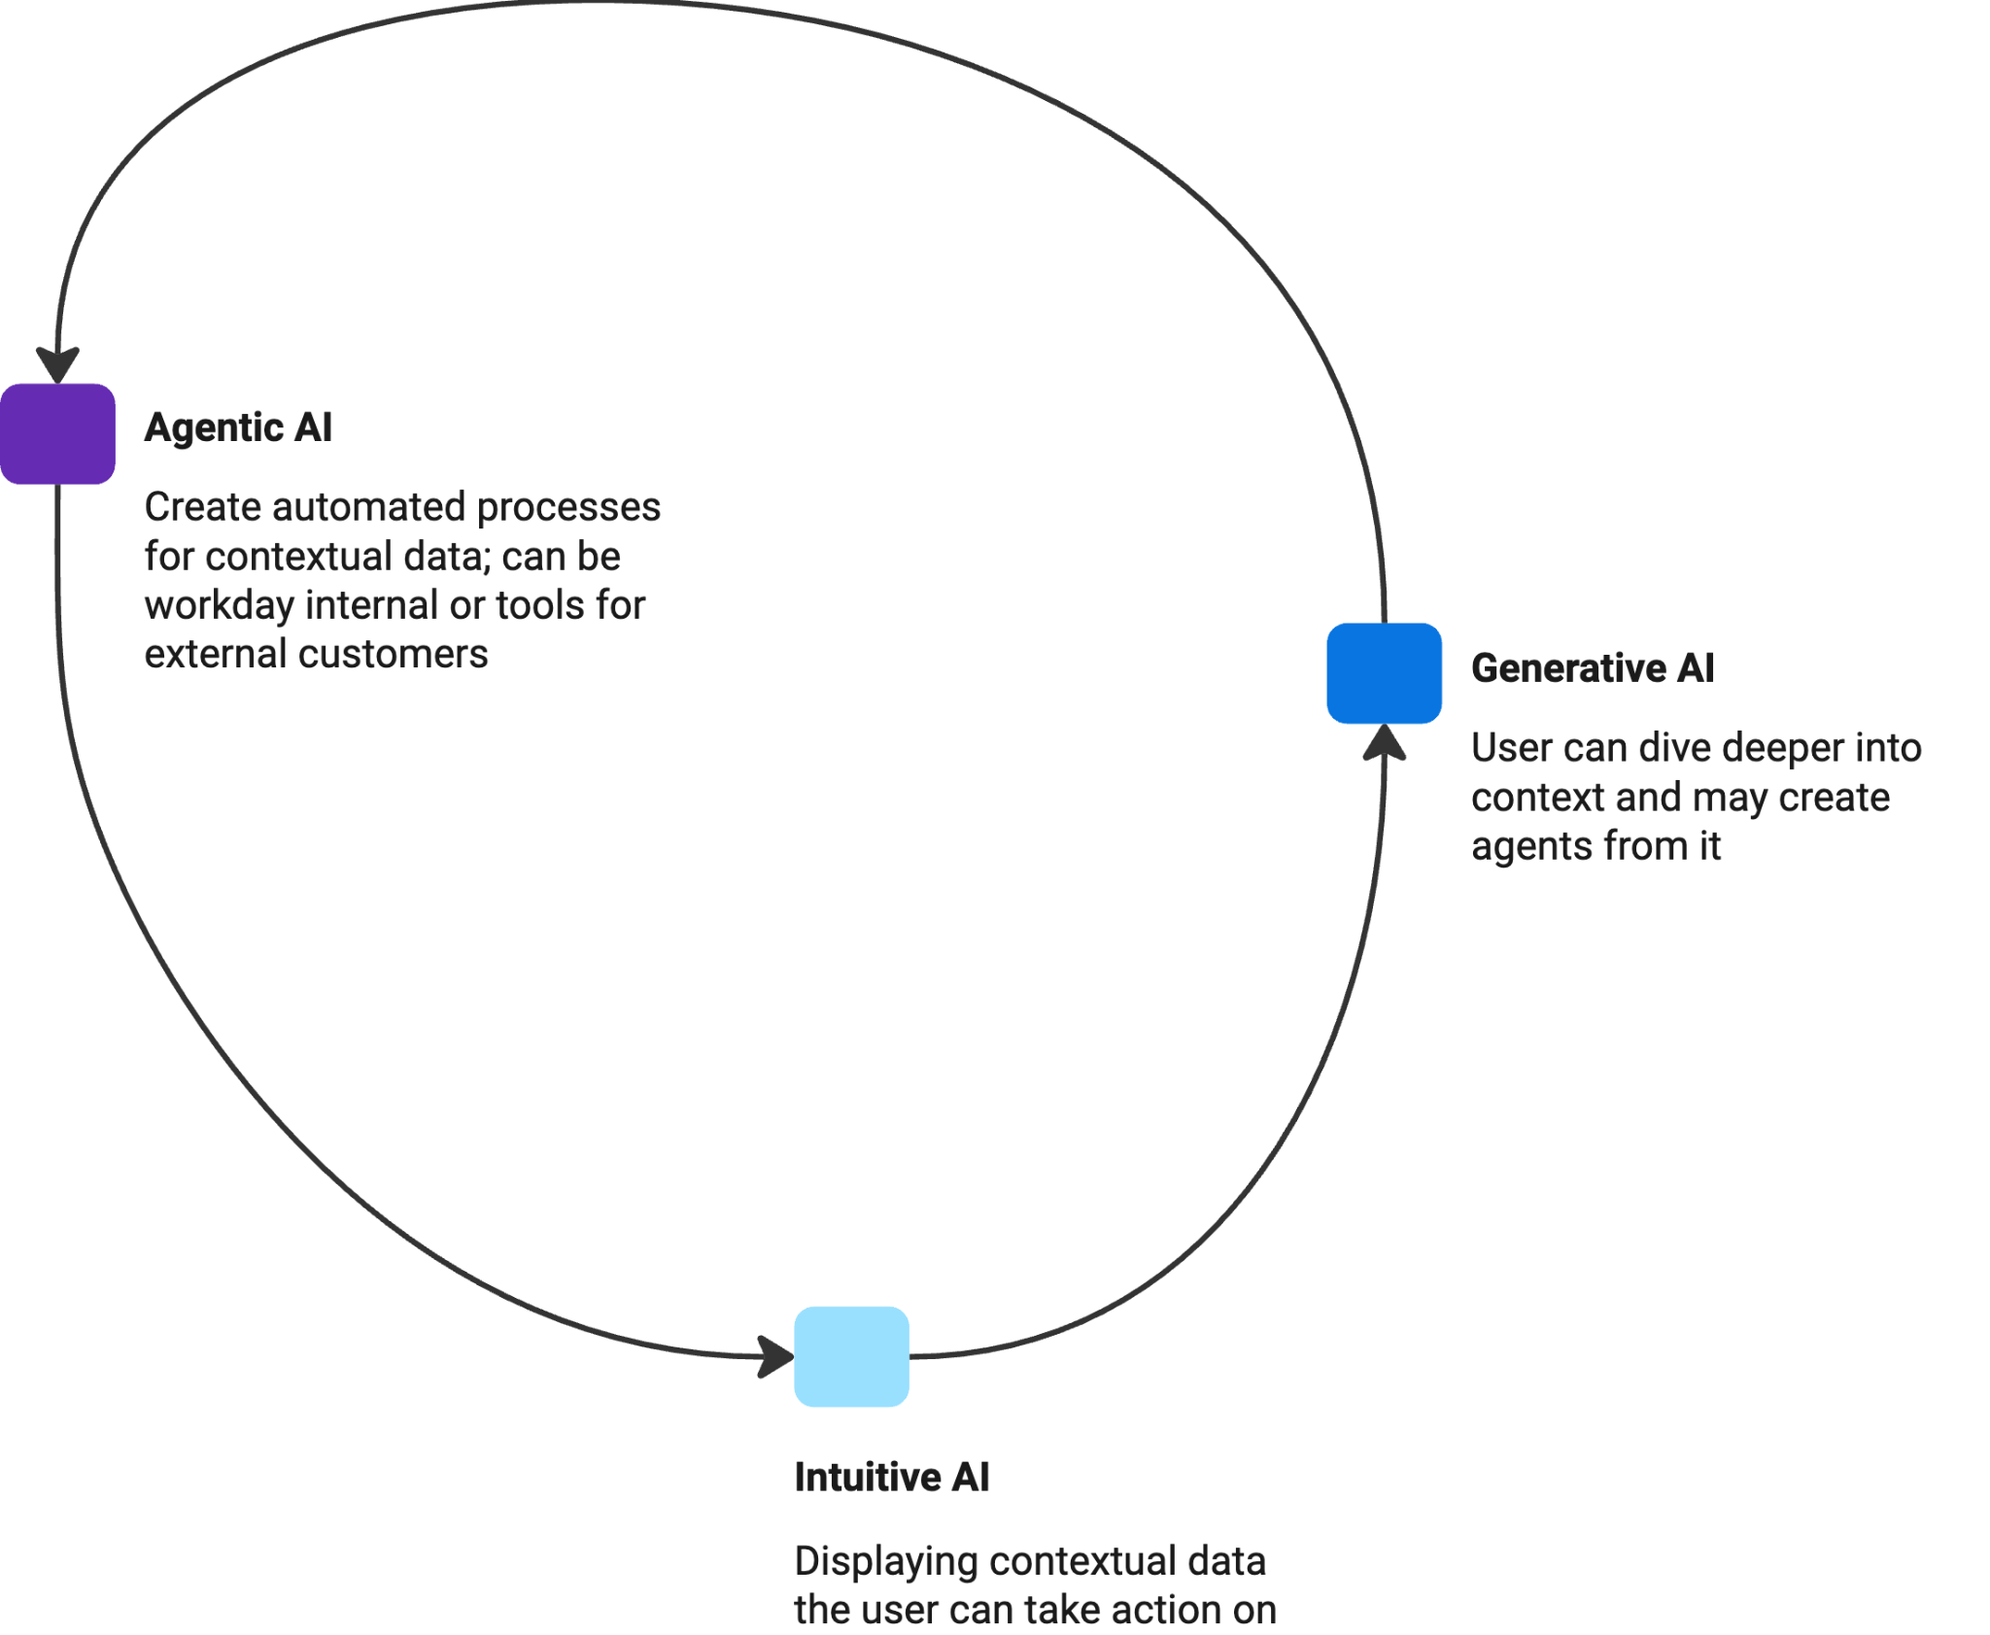

McGrenere, J., Baecker, R., & Booth, K. S. (2002). An evaluation of a multiple interface design solution for bloated software. Proceedings of CHI 2002.
Jameson, A. (2003). Adaptive interfaces and agents. In The Human-Computer Interaction Handbook (pp. 305–330). Lawrence Erlbaum Associates.
Porcheron, M., Fischer, J. E., Reeves, S., & Sharples, S. (2018). Voice interfaces in everyday life. Proceedings of the 2018 CHI Conference on Human Factors in Computing Systems.
Myers, B. A., Weitzman, L., Ko, A. J., & Chau, D. H. (2006). Crystal: support for collaborative task management. ACM CHI 2006 Extended Abstracts.
Lee, J. R., & Chen, N.-C. (2021). Iterative Co-Creation with AI: Understanding Experienced Designers' Perceptions of Generative AI in the Creative Workflow. Creativity and Cognition.
Choi, J. H., & Conradi, C. (2020). Creating with AI: Challenges to Co-Creative Practices. DIS 2020 Workshop on Co-Creation with AI. Nielsen Norman Group. (2023). Designing for Generative AI: 7 Key Considerations.Available at nngroup.com.
Liao, Q. V., Gruen, D., & Miller, S. (2020). Questioning the AI: Informing Design Practices for Explainable AI User Experiences. CHI 2020. (Though focused on explainability, similar principles apply to controlling how often AI intervenes.)
Lubart, T. (2005). How can computers be partners in the creative process: Classification and commentary on the special issue. International Journal of Human-Computer Studies, 63(4–5), 365–369.
Luger, E., & Sellen, A. (2016). "“Like having a really bad PA”: The gulf between user expectation and experience of conversational agents." CHI 2016. This study suggests that users become frustrated when agents act too independently or too often without user input.
Amershi, S., et al. (2019). "Guidelines for Human-AI Interaction." CHI 2019. These guidelines highlight that users should be in control of how frequently AI surfaces, suggesting minimal and meaningful interventions build trust and prevent overload.
Amershi, S., et al. (2019). "Guidelines for Human-AI Interaction." CHI 2019. These guidelines highlight that users should be in control of how frequently AI surfaces, suggesting minimal and meaningful interventions build trust and prevent overload.
Amershi, S., et al. (2019). "Guidelines for Human-AI Interaction." CHI 2019. These guidelines highlight that users should be in control of how frequently AI surfaces, suggesting minimal and meaningful interventions build trust and prevent overload.
McGrenere, J., Baecker, R., & Booth, K. S. (2002). An evaluation of a multiple interface design solution for bloated software. Proceedings of CHI 2002.
Jameson, A. (2003). Adaptive interfaces and agents. In The Human-Computer Interaction Handbook (pp. 305–330). Lawrence Erlbaum Associates.

